|  |
| --- |
|  |
| Module Name: Computing Project (CP)  Hotel Order Management System  Submitted by: Sudeep Bhattarai  Submitted to: (**Sudeep Lal Bajimaya**)  NCC ID: 00175876  Batch: 23 ‘A’ |

**Table of Contents**

Chapter 1 Introduction 2

1.1 Project Introduction 2

1.2 Justification for the project 2

I. Background of the project 2

II. Problem Statement 2

1.3 Description of the project 3

Features 3

1.4 Overview 3

Chapter 2 Scope of the project 4

2.1 Scope 4

2.2 Limitation 4

2.3 Amis 4

2.4 Objective 4

2.5 Overview of the scope 4

Chapter 3 Development Methodology 5

3.1 Methodology 5

3.2 Design Pattern 6

3.3 System Architecture 8

Chapter 4 Project Scheduling 9

4.1 Work breakdown system 9

4.2 Milestone 10

4.3 Scheduling / Gannt Chart 12

Chapter 5 Risk Management 14

Chapter 6 Configuration Management 16

Conclusion 17

# Chapter 1 Introduction

## 1.1 Project Introduction

We are living in the era of automation. Business in the hospitality industry has been greatly influenced and competition has increased due to improved food ordering techniques and automated systems. In order to effectively run a restaurant or hotels, time saving and cost optimizations are essential. Reduction in time by a few seconds for each table can speed up order processing, increase efficiency and boost profits. My project is to create an online hotel ordering and billing system website for an additional amenity in luxurious hotels. In order to create my project, I will be using a specific programming language PHP, MySQL as a database, JavaScript, bootstrap, jQuery.

## Justification for the project

### Background of the project

The food ordering system, till a few years ago, was a completely manual process where a waiter used to note down orders from the customers using pen and paper, take the orders to the kitchen, bring the food and make the bill. Although this system was simple it required extensive investment in purchase and storage of paper, large manpower and also was prone to human errors and greater time consumption.

In order to overcome these limitations in manual system, a system can be developed like creating a websites containing all the features of ordering and billing in the hotel where costumer can get efficient and effective service and get notified about the process. User get in touch with the counter table and kitchen screen about the order taken and bills are counted automatically in each table of the order.

### Problem Statement

The module of the system and its algorithm to use may be inconvenient to the user The digitalized technique is advantageous for the efficiency and tame reliable but ordering point is needed to be considered because some costumer may want to reduce food content for their health like oil, sweet etc. And for this additional terms can be added to describe their order. User may be required training to use such system so focusing on those contents and build the system in an easy manual for the zero error and reduce the problem that could be faced by the user on its uses.

## Description of the project

### Features

Following features will be included on the system:

* **Provides notification of the activity performed by the user.**

The activity of taking order and kitchen process are notified to the costumer on the screen

* **Provide an interface to add product and their respective price.**

The products and their prices are detailed on the interface to select as an order.

* **Provides total sales between selected period.**

The sales report is captured by the time

* **Calculates the amount of the order.**

Amount of the order is calculated instantly.

* **Print the bill of the order.**

The bill of the order can be printed simultaneously.

* **Orders to be made ready is displayed in cook display board.**

The taken order is displayed on the screen in the kitchen board.

* **Customer order status is displayed in the screen near to the table.**

The ordered items with its status is shown in the screen near the table

## Justification of the Project

Within this all features the hotel can create a clear and convenient environment of services within the costumer along with the problem listed above is fixed by the additional features of note given by the costumer for their health purposes. User can bear their fast services and interact positively with the costumer. Some more features of taking reviews and feedbacks are added so that the problem and unsatisfaction can be detected and hotel can take actions against it.

# Chapter 2 Scope of the project

## 2.1 Scope

Managing the orders and bills is the main theme and scope of this project so that costumer can have efficient way of celebration or fooding. And also the account and the misbalance between the staffs can be reduced.

## Limitation

Instead the project is reliable for the costumer to get order within a time there are some limitations under the management system. Some of them are listed below:

* The algorithm and manual to use the system may not be applicable to the user they may need trainings for this.
* The whole order and billing system is responsible for the account. Data may be crashed or lost due to internal threats which causes irrelevant accountation.

## 2.3 Aims

Fast service and easy ordering and monitoring is the main aim of the project. Replacing the paper note ordering system the aim to save time and fast delivery can optimize the profit by growth in sales. Some of the point listed aims are:

1. To provide fast ordering and serving system in a standardized pattern.
2. To provide monitoring system to inform about the order in each of the table.
3. To make the portable ordering system which helps user to take order in different table at a time and give order to the kitchen at a time with notification.

## Objective

Dominating the current system of ordering with the technical and standardized system with the advantage of fast and easy ordering and billing system the functions are featured as an objective in this system some of the objectives of this management systems are listed below:

* Creating the database that is normalized after understanding the attribute and relation between the entities.
* Designing user friendly UI which is simple and easy to use.
* Providing robust login system for admin users.
* Design a simple interface to add different product and its price.
* Designing a cook display board, table display board and order booking interface.
* Making these interfaces dynamic.
* Making these interface to update automatically.

## Overview of the scope

There cannot be the system without limitation but beside these all the scope of this hotel order management system is to keep the clean records and aim to give a fast and easy ordering and billing system contextually. Concept to this system gives benefits in sales and management of an entire hotel by clean record of orders and bills. In overall study of this objectives and features given the system gives a luxurious way of giving services to the costumer.

# Chapter 3 Development Methodology

## 3.1 Methodology

The entire project has been involved in a Waterfall model where various steps of development are involved in next to next format. In this method of development sequential pattern of steps is involved where the steps are completed and only moved to next steps of process where each of the step have its distinct role to be done.

Firstly, every requirement is listed with class then The system is designed according to the requirements listed. After while Implementation is done where the entire system is formed or developed. Next step includes testing in which overall system are tested for additional requirements needed then the product is released. Lastly the maintenance and upgrades are added that were detected while testing.

* **Advantages of Waterfall Model are:**

1. Understandable and easy to use,
2. For small schemes where supplies are well understood it is more effective.
3. Task can be arranged easily.

* **Disadvantages of Waterfall Model are:**

1. Doubt are unclear with maximum possibility of risk.
2. Accommodation to changing requirement are not suitable.
3. The process model is not efficient with the projects where requirements are at moderate to high risk of replacement and changes.

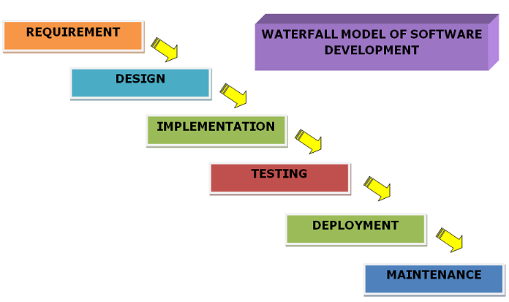

Figure 1: Software development life cycle

Waterfall model of SDLC is accurate methodology for this project as the project tends to be less complex and small scaled oriented.

## Design Pattern

**Model View Controller (MVC)** design pattern is used as the design pattern for this project as it is commonly used mostly of the programming language nowadays which is effective and easy to understand. Both desktop-based and web based can use MVC design pattern commonly used by most of the programming language. Here **Model** represents an object which has logic to update the data changes. **Views** represents the visualization of the data contained and **Controller** represents the act of both model and view that controls data flow into the objects and update the data changes.

**Advantages of MVC pattern are:**

1. It offers support for quick and parallel development that helps in developing web application by dividing the work where View and Controller are worked by different developer.
2. It supports Asynchronous Technique in web application that it can be madeto work even with PDF files, site that runs only on the specific browser, and also for desktop widgets.

**Disadvantages of using MVC pattern are:**

1. As they each are isolated the complexity is high in development of the application using this pattern there is no idea of work done by model view and controller.
2. With the application’s performance and architecture, it is not suitable for the small application which gives adverse effect.

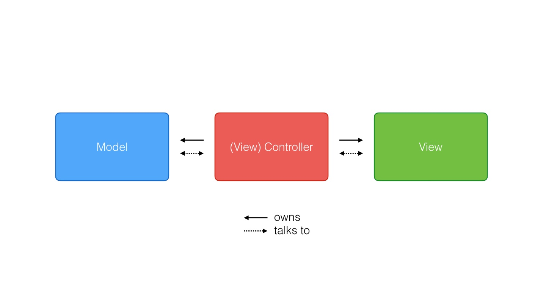

Figure 2: Design pattern used (MVC)

## 3.3 System Architecture

A system architecture defines the fundamental union of the system with its components ambled with their relationships and the environment with the theme of governing its design and evolution that helps to briefly system behavior, system view and its structure which is conceptual. Three-tier Architecture is used for this project like:

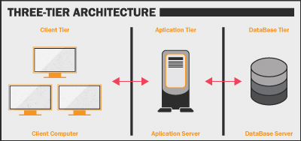

Figure 3: System Architecture (3- tier architecture)

# Chapter 4 Project Scheduling

## 4.1 Work breakdown system

It is the process of dividing the complex form of development to the simple form that helps in perform the work and divide time interval with its complexity.

## Milestone

It is often known as the planning or scheduling of the contents of the task of the project that helps to complete any project in required interval of time. Milestone is also known as the visual indicator of the progress of the project towards its objectives which is also helpful in understanding the structure of the project.

|  |  |  |  |
| --- | --- | --- | --- |
| **Hotel Order Management System** | | | |
| **WBS number** | **Milestone** | **Date (2019)** | **Days** |
| **1** | **Proposal** | **(16 June – 1 July )2019** | **16 days** |
| 1.1 | Scope and objectives | 16 June- 19 June | 4 days |
| 1.2 | WBS, Milestone and Gantt Chart | 20 June – 23 June | 4 days |
| 1.3 | Risk Management | 24 June – 26 June | 3 days |
| 1.4 | Configuration Management | 27 June – 29 July | 3 days |
| 1.5 | Submission | 30 July– 1 July | 2 days |
| **2** | **Analysis** | **(2 July- 29 July) 2019** | **28 days** |
| 2.1 | Feasibility study | 2 July- 13 July | 12 days |
| 2.2 | Requirement Specification | 14 July – 26 July | 13 days |
| 2.3 | Use Case Diagram | 27 July – 29 July | 3 days |
| **3** | **Design** | **(30 July – 29 August) 2019** | **31 days** |
| 3.1 | Structural Model  [Class Diagram] | 30 July – 6 August | 8 days |
| 3.2 | Behavior Model | 7 August – 14 August | 8 days |
| 3.3 | Database design  [ER diagram]  [Data-Dictionary] | 15 August – 22 August | 8 days |
| 3.4 | User Interface (UI) Design | 23 August - 29 August | 7 days |
| **4** | **Coding** | **(30 August – 20 September) 2019** | **22 days** |
| 4.1 | Build Database | 30 August – 7 September | 9 days |
| 4.2 | Implementation of code | 8 September – 20 September | 13 days |
| **5** | **Testing** | **(21 September – 30 September) 2019** | **10 days** |
| 5.1 | Black Box Testing | 21 September- 23 September | 3 days |
| 5.2 | Unit Testing | 24 September – 27 September | 4 days |
| 5.3 | Validation Testing | 28 September- 30 September | 3 days |
| **6** | **Documentation** | **(1 October – 12 October) 2019** | **12 days** |
| 6.1 | User Manual | 1 October – 8 October | 8 days |
| 6.2 | Final Report | 9 October - 12 October | 4 days |

## 4.3 Scheduling / Gannt Chart

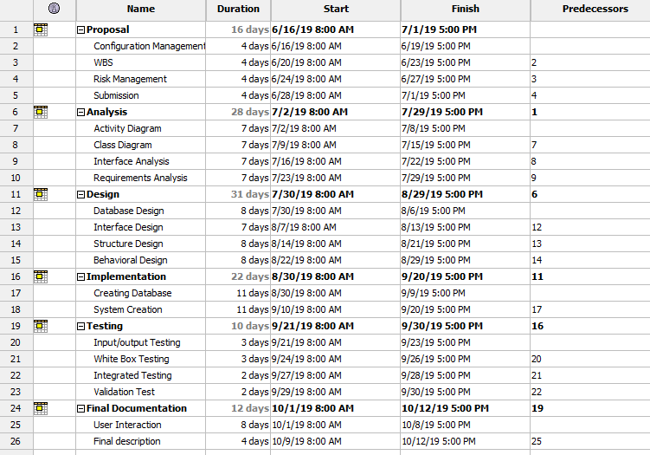

Figure 4: WBS in Project Libre

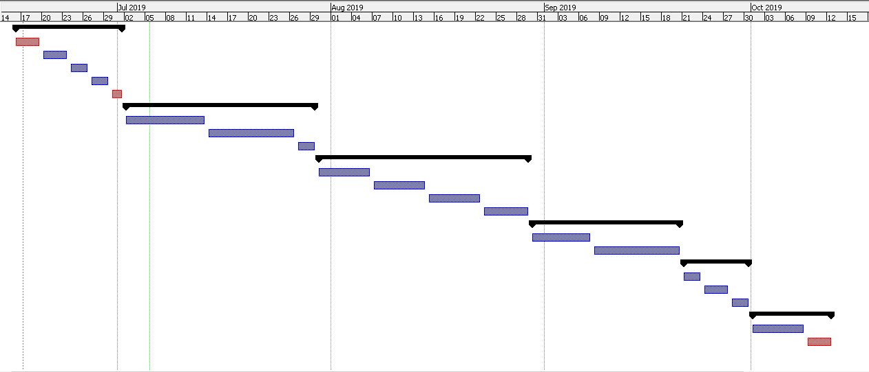

Figure 5: Gantt Chart

# Chapter 5 Risk Management

The identification and controls over the threats of an organization’s investment and grossing that arises from the extreme variety of sources including all the financial uncertainty, legal labiates, strategic management errors, natural disasters of other type of accidents is known as Risk management.

**Identify the Risk**

Identification of the risk is the most part in a project. Different techniques are used to identify the Risk like:

1. **Analyze the Risk**

We analyze the potential of harming a project of a risk and understand the management system goals and objectives with the likelihood and consequences.

1. **Evaluate or Rank the Risk:**

After the consequences and likelihood are analyzed we bother its acceptance if is serious enough for the warrant treatment.

1. **Treat the Risk**

The highest ranked risk is accessed and planned for the treatment for minimizing the negative risks.

1. **Review the Risk**

In this process we take the risk as a point and trace the review for the risk.

The impact on the system can be calculated by using following formulae

**Impact = Likelihood X Consequences**

|  |  |
| --- | --- |
| **Likelihood Table** | |
| **Likelihood** | **Value** |
| Low | 1 |
| Medium | 2 |
| High | 3 |

|  |  |
| --- | --- |
| **Risk Consequences Table** | |
| **Consequence** | **Value** |
| Very low | 1 |
| Low | 2 |
| Medium | 3 |
| High | 4 |
| Very high | 5 |

**Risk Management table:**

|  |  |  |  |  |  |
| --- | --- | --- | --- | --- | --- |
| **RID** | **Risk Name** | **Likelihood** | **Consequence** | **Impact** | **Solution** |
| 1 | Bug on the Code | 2 | 2 | 6 | Proper testing should be done before deployment. |
| 2 | Server failure | 1 | 5 | 5 | Backup should be done time to time |
| 3 | Untrained Developer | 1 | 5 | 5 | Proper training should be given. |
| 4 | Malware/ Virus | 2 | 5 | 10 | Antivirus and anti-malware software should be installed. |
| 5 | Strategy Risk | 2 | 5 | 10 | A well plan project should be implemented |
| 6 | External Factors | 1 | 3 | 3 | Proper safety measures for hazards. |

# Chapter 6 Configuration Management

To ensure consistency among the physical and logical assests Configuration management is done in an operational environment. It is often known as system engineering consistency. environment.

It helps to classify documenting functional capabilities, individual configuration item and interdependencies. I will be keeping all the progress in the GitHub. I’ll also backup every change in my project development.

In order to access the file anytime from anywhere, here in GitHub, files and folders are managed in systematic way.

Link of my profile:

<https://github.com/sudeepbhattarai100/CP_Project>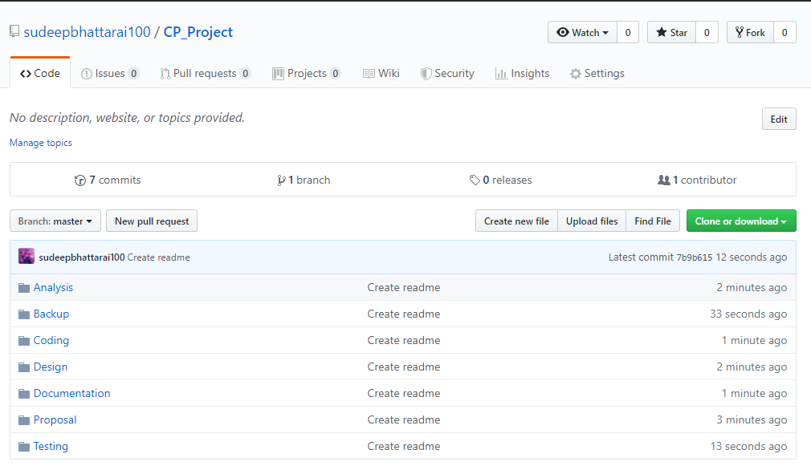

Figure 6: Configuration management (GitHub)

# Conclusion

After all the process of acylation the management system is ready to be released on market that can be affordable and use it to make a hotel or restaurant more luxurious, with all the facility and feature hotel management can be easier and there may be satisfaction in business between costumer and the hotel itself.

In overall process of development Bracket as a text editor is used and MYSQL as a database and Apache as a local server.